**Pre-Quiz : TSQL**

**Post-Quiz : TSQL**

**Pre-Quiz : Stored Procedures**

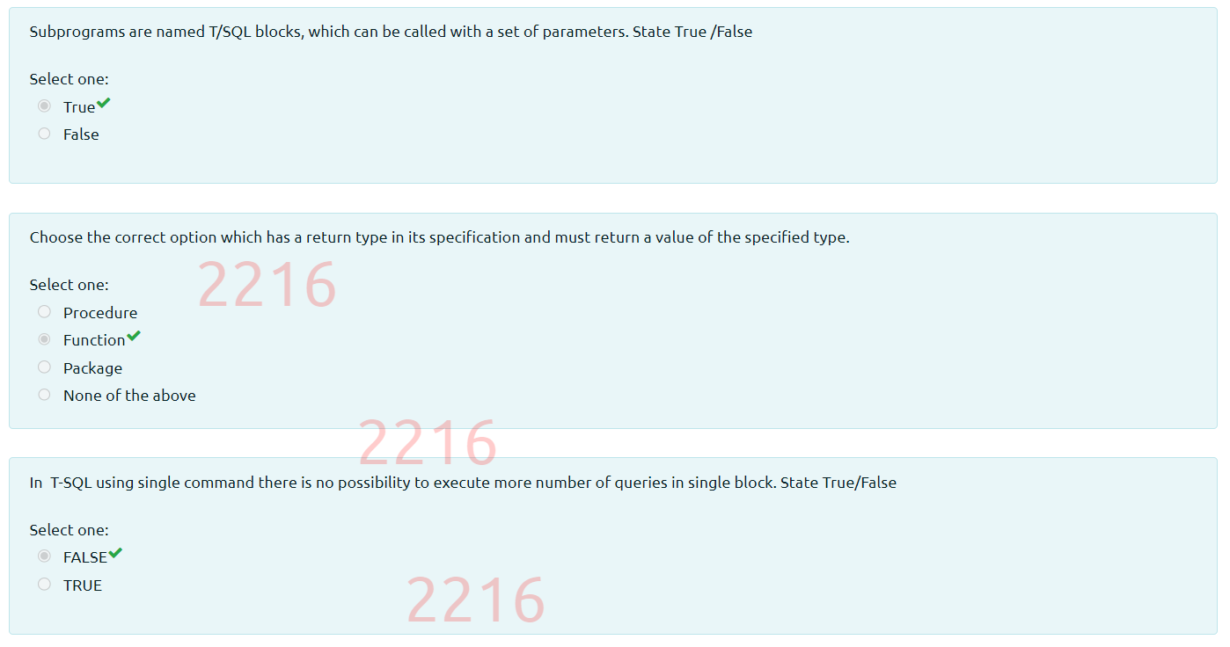

**Post-Quiz : Stored Procedures**

**Pre-Quiz : Exceptions**

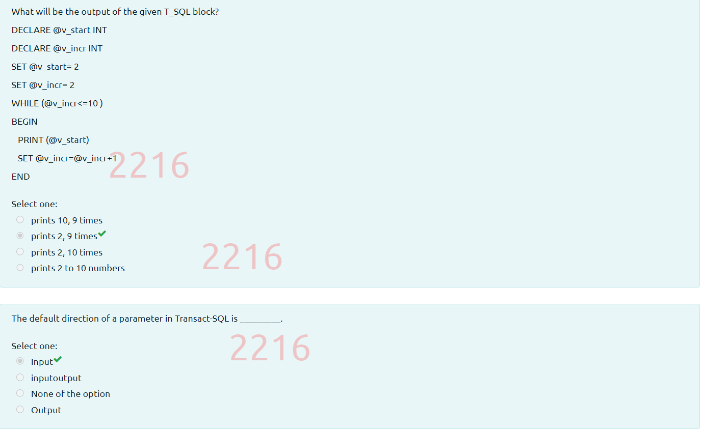

**Post-Quiz : Exceptions**



